Problem Statement 6: Design a Relational Database Model Azure SQL Database

* I created a blank database in Azure SQL Database
* I created a server-level IP firewall rule in my SQL databse. This firewall prevents external applications and tools from connecting to the server. To enable external connectivity to my database, I added an IP firewall rule for my IP address.
* I created a database schema with four tables that model a student management system for universities.
* I loaded fake data into the tables; Person table which include the Personid(INT) as the primary key, FirstName(VARCHAR), MiddleInitial(VARCHAR),LastName(VARCHAR), DateofBirth(DATE NOT NULL). Also the Student table which has the StudentId as the primary key, the Course table which has CourseId as the primary key and the Grade table and the Attempt table.
* I had to drop some rows while creating my table because I put in the wrong data type. I then recreated it and insert the right data type.
* I executed the queries to retrieve information from the Database tables, and it was successful. 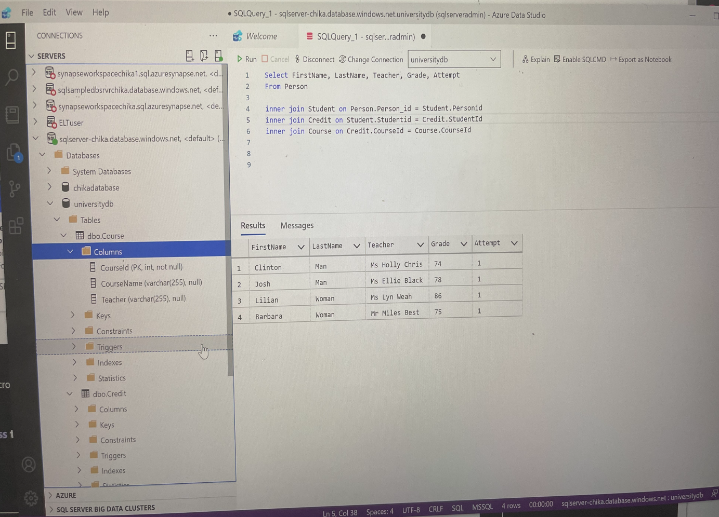

Figure 1: SQL Query displaying the tables

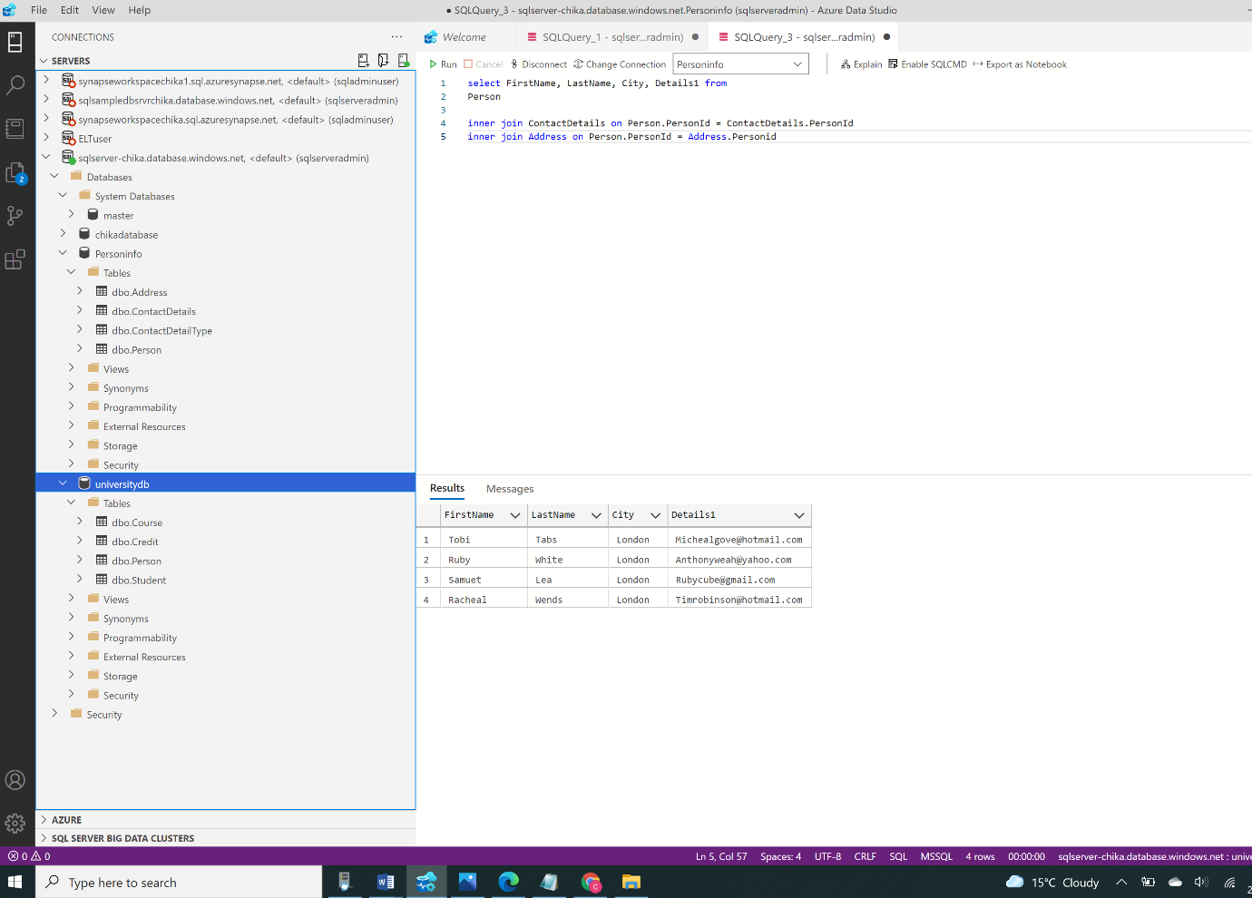

Figure 2: SQL Query displaying the table in my University DB